

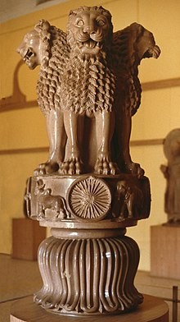



ADHAAR- AAM ADAMI KA ADHAAR



GOVERNMENT OF INDIA

0000 1111 2222

NAME-XXXX

DOB-XX-XXX-XXXX

GEBDER- MALE